Screen Documentation
Introduction
This document describes each screen of the Expense Tracker application, including its purpose, UI components, and navigation.

- Splash Screen

Purpose
Displays the application logo while loading the application.

Components
- App Logo
- App Name
- Background Image

Navigation
Splash
↓
Onboarding

- Onboarding Screen
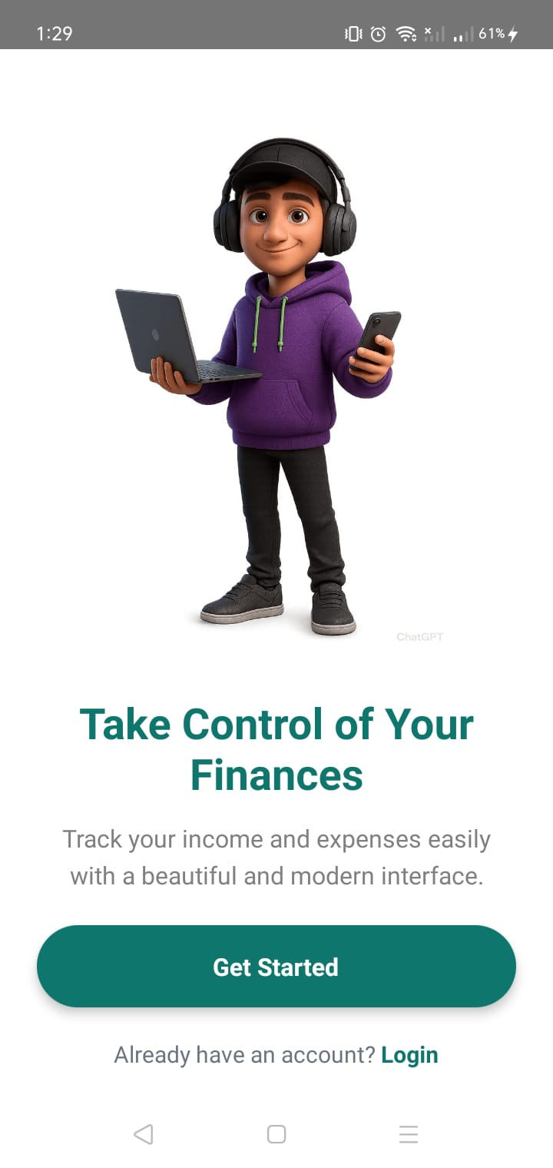

Purpose
Introduces the application's features to first-time users.

Components
- Carousel Images
- Feature Description
- Next Button
- Skip Button
- Get Started Button

Navigation
Onboarding
↓
Login

- Login Screen
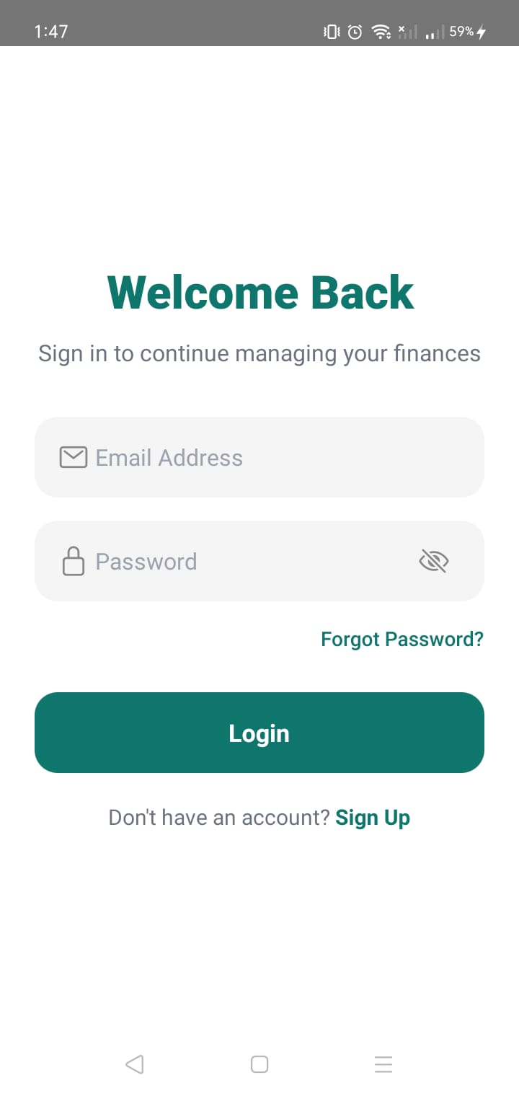

Purpose
Allows registered users to log into the application.

Components
- Email TextField
- Password TextField
- Show/Hide Password
- Login Button
- Forgot Password
- Sign Up Link

Navigation
Login
Forgot Password
Sign Up
Home (Bottom Tabs)

- Sign Up Screen

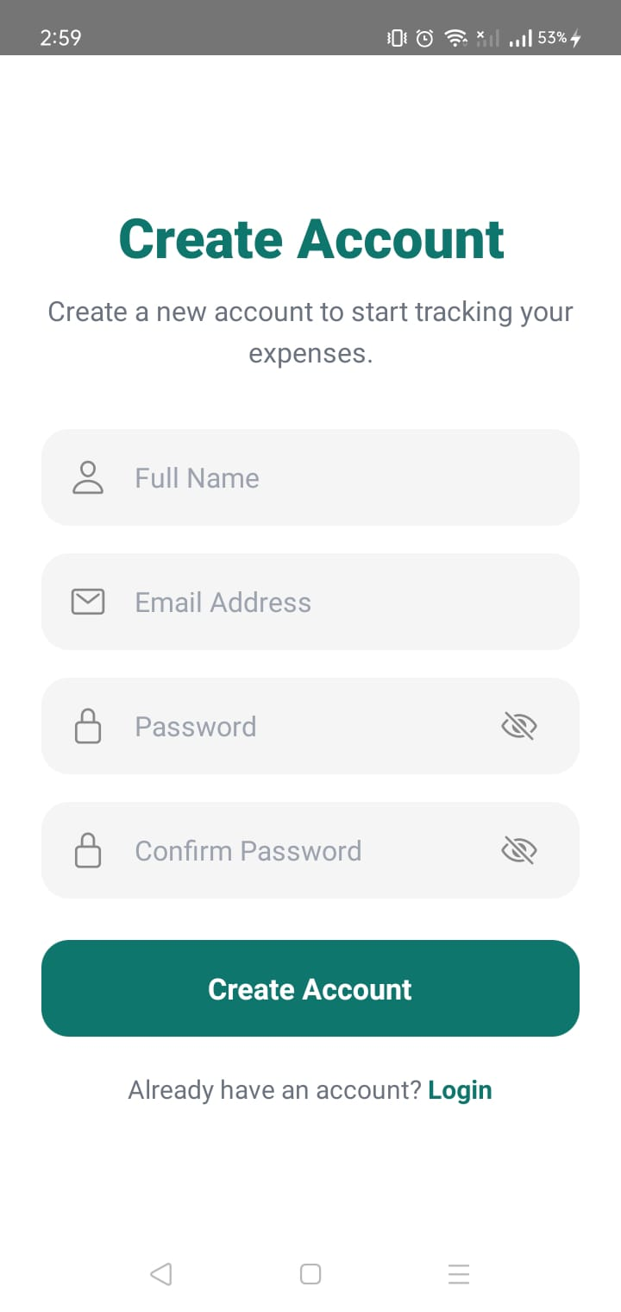
Purpose
Creates a new user account.

Components
- Full Name
- Email
- Password
- Confirm Password
- Create Account Button

Navigation
Sign Up
↓
Login

- Forgot Password
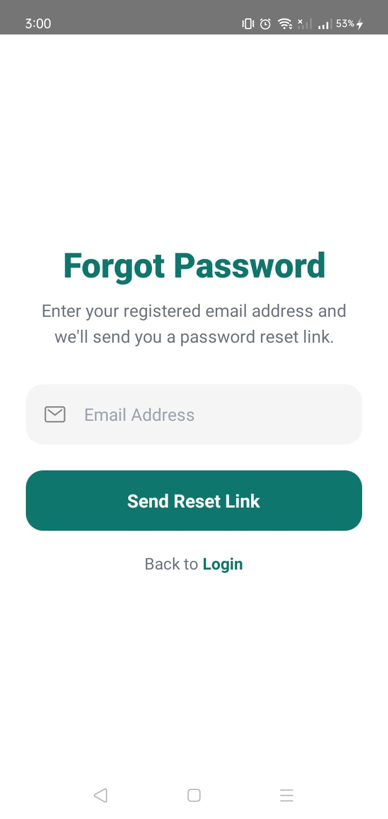

Purpose
Allows users to reset their password.

Components
- Email TextField
- Send Reset Link Button

Navigation
Forgot Password
↓
Login

- Home Screen
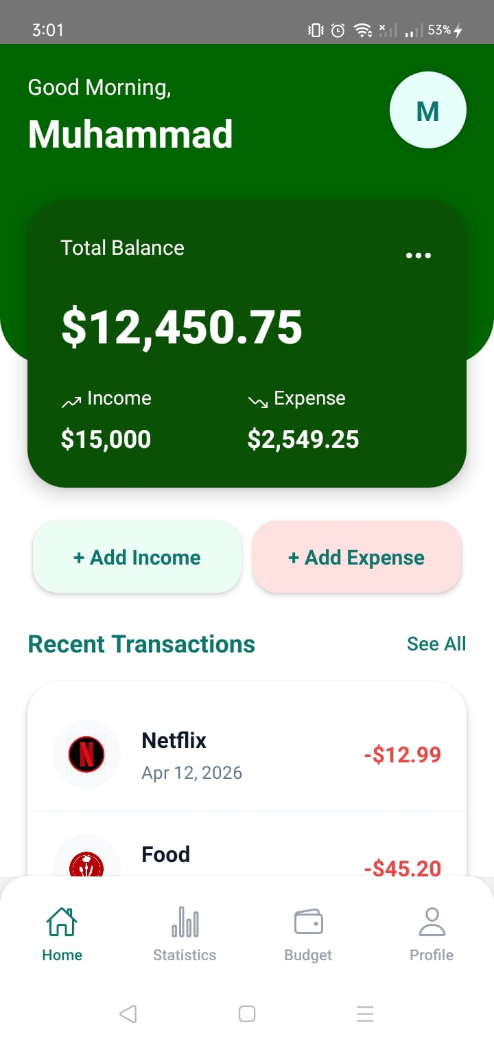

Purpose
Provides an overview of the user's financial status.

Components
Header
- Greeting
- User Avatar
Balance Card
- Total Balance
- Income
- Expense
Quick Actions
- Add Income
- Add Expense
Recent Transactions
Transaction List
See All Button

Navigation
- Home
- Add Income
- Add Expense
- Transactions
- Profile

- Statistics Screen
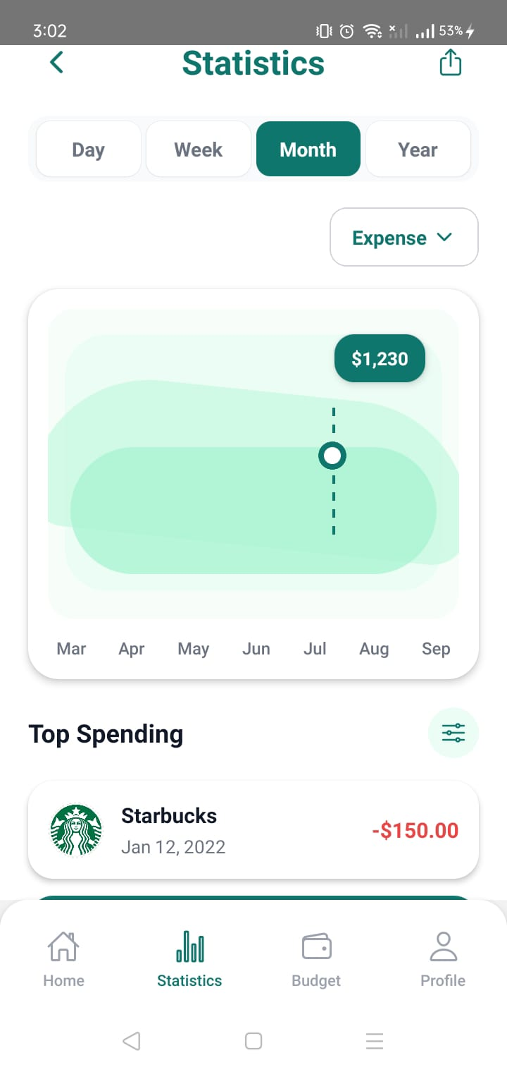

Purpose
Displays graphical financial statistics.

Components
- Week
- Month
- Year Selector

Overview Cards
- Income
- Expense

Expense Overview
Top Categories

Navigation
Statistics
(No additional navigation)

- Wallet Screen
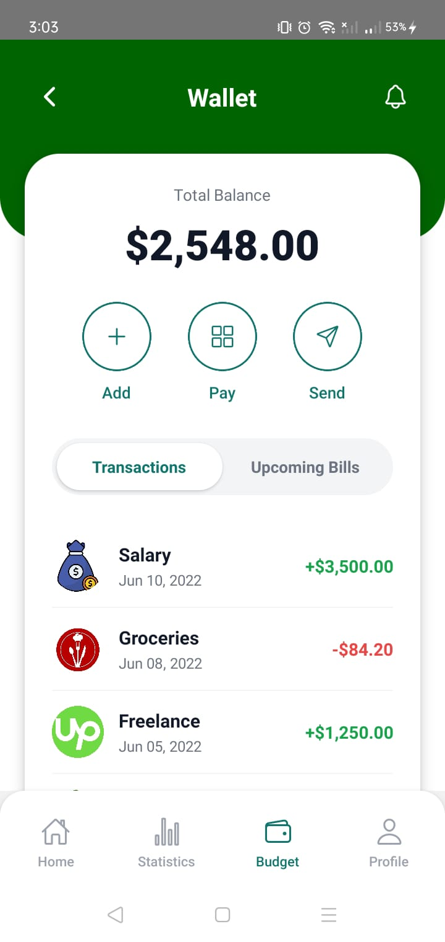

Purpose
Allows users to manage wallet balance and payments.

Components
Header
- Back Button
- Wallet Title
- Notification Icon
Wallet Card
- Total Balance
Quick Actions
- Add
- Pay
- Send
Tabs
- Transactions
- Upcoming Bills

Navigation
Wallet
↓
Connect Wallet

- Connect Wallet
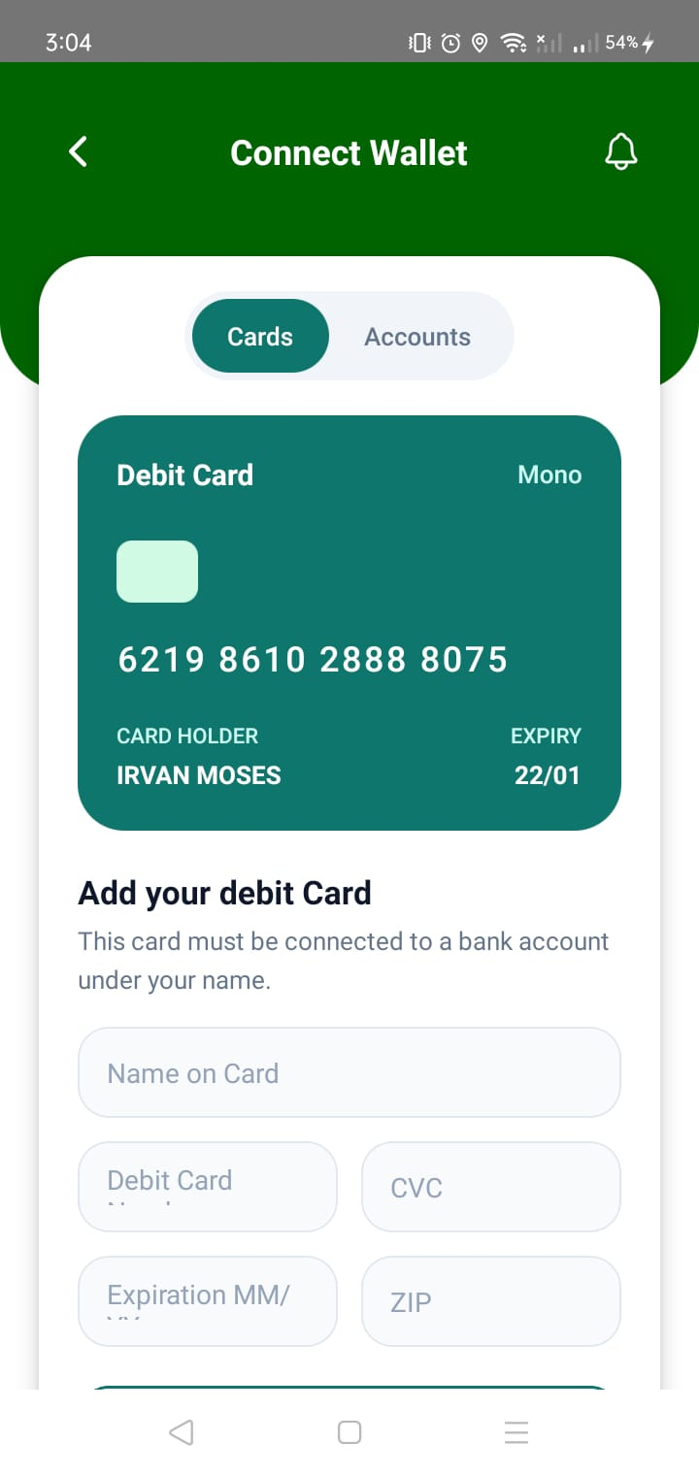

Purpose
Allows users to add debit cards.

Components
- Cards / Accounts Segment
- Card Preview
- Card Form
- Next Button

Navigation
Connect Wallet
↓
Connect Wallet Accounts

- Connect Wallet Accounts
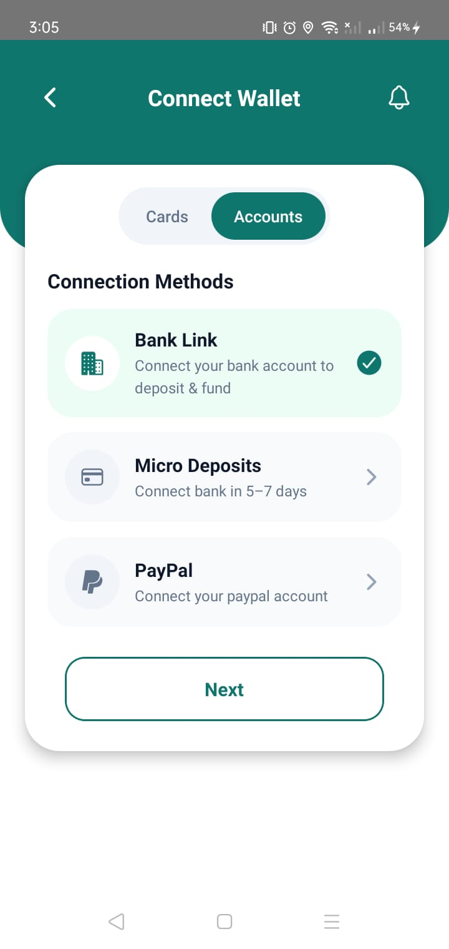
Purpose
Allows users to choose a payment connection method.

Components
- Bank Link
- Micro Deposits
- PayPal
- Next Button

Navigation
Connect Wallet Accounts
↓
Wallet Connected (Future)

- Profile Screen
Purpose
The Profile screen allows the user to view their profile information and access account-related settings.
Header
- Green background
- Back arrow
- Profile title
- Notification icon

Profile information
- Profile image
- User name
- Username/email

Menu options
- Invite Friends
- Account Info
- Personal Profile
- Message Center
- Login and Security
- Data and Privacy

Bottom navigation
- Home
- Statistics
- Wallet
- Profile

Components
- Profile Image
- Profile avatar
- Name
- Email
- Settings
- Edit Profile
- Notifications
- Security
- Help
- Logout

Navigation
Profile
↓
Edit Profile
↓
Settings
↓
Logout

Account Info
↓
Edit Profile

Login and Security
↓
Change Profile

- Edit Profile Screen
Purpose
Allows the user to modify personal and account information.

Fields
- Full Name
- Email
- Phone Number
- Username
- Country
- Currency

Additional UI
- Profile image
- Camera button
- Back button
- Save Changes button

Current behavior
- User can edit the fields locally using React Native state.
- Pressing Save Changes calls navigation.goBack() and returns to Profile.
- No backend persistence has been implemented yet.

Document Information
Version: 1.0
Author: Muhammad Haseeb
Status: In Progress
Last Updated: 10 August 2026

